User’s Guide
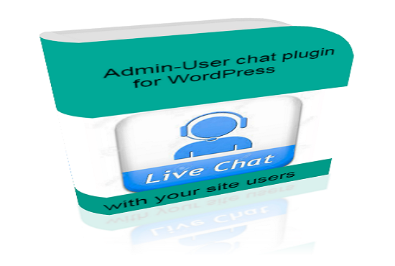

Table of Contents

Introduction 3
Setting the Style Widget 4
General 4
Tab Button 5
Header 7
Footer 9
Main Content 10
Chat Bubble 12
Form 13
Effect 15
Adjusting Chat Features 17
General 17
Content 18
FORM 19
USER 21
NOTIFICATION 22
ADMIN CHAT 23
OFFLINE MESSAGE 24

Introduction

WP Visitor Chat plugin creates a live chat widget on your website allowing site visitors to directly interact with the administrator in real-time or offline mode. With this plugin, visitors can send a short message to you can quickly do so right from the website.

The WP Visitor Chat plugins comes in two editions: the full edition and lite edition. The following features are available only in the full edition and missing in the lite edition.

- Users List
- Setting Background Image & Button Icon
- Settings Chat Bubble
- Settings Input Form
- Settings Widget Effect
- Notification

Setting the Style Widget

The default style that comes with the plugin is quite simple, but it is very easy to change and customize to your desired look. Here is how to set the various options for the widget.

To access the Widget Settings page, simply navigate to it from the WordPress Dashboard as shown below.

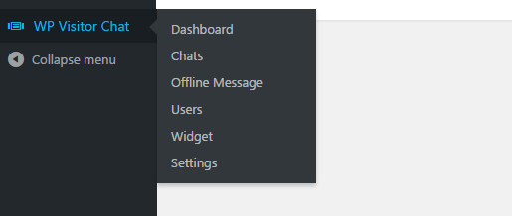

The following describes the various options available.

General
This section contains options to set the widget display style.
1. Widget Width -- Sets the width of the widget.
2. Templates -- Sets the template or style type of the widget.

3. Position -- Sets the position of widgets on the web page.

Tab Button
This section contain options to customize the look of the tab key. The following options are available:
4. Button Label -- Sets the label of the tab key.
5. Button Icon -- Sets the icon of the tab key.
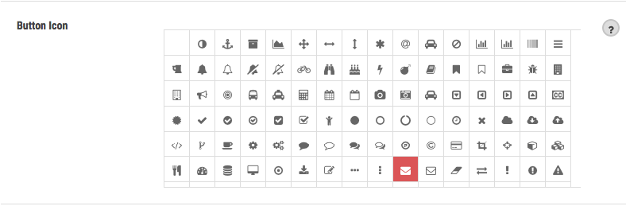

6. Width -- Sets the width of the tab key.

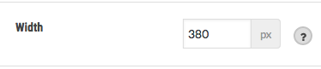
7. Height -- Sets the height of the tab key.

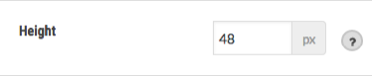
8. Background Color -- Sets the background color of the tab key.
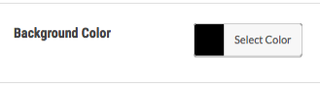
9. Border -- Sets the margins of the tab key.
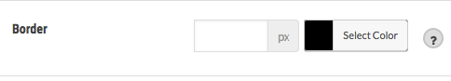
10. Border Radius – Sets the curvature of the line the edge of the tab key.
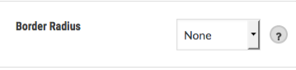
11. Text Color -- Sets the text color of the tab key.
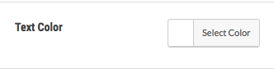
12. Font Size -- Sets the font size of the tab key.
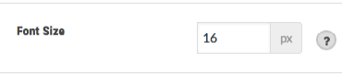
13. Font Family -- Sets the type font of the tab key.

Header
This section contains options for the header. The following options are available:

14. Header Text -- Sets the text of a section header.
15. Height -- Sets the height of the header.
16. Background Color -- Sets the background color of the header.
17. Background Image -- Sets the background image of the header.

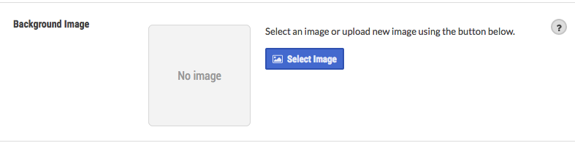
18. Background Repeat -- Sets the type of repetition of the background image of the header.
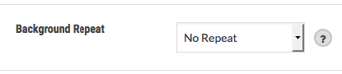
19. Background Opacity -- Sets the transparency level of the background image of the header.
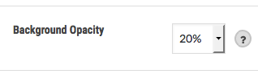

20. Border -- Sets the margins of the header.
21. Border Radius -- Sets the curvature of the edge line of the header.
22. Text Color -- Sets the text color of the header.
23. Font Size -- Sets the font size of the header.
24. Font Family -- Sets the font type from the header.

Footer
This section contains options to set the footer information.
25. Footer Text -- Sets the text of the footer.

26. Height -- Sets the height of the footer.
27. Background Color -- Sets the background color of the footer.
28. Border -- Sets the margins of the footer.
29. Border Radius -- Sets the curvature of the line the edge of the footer.
30. Text Color -- Sets the text color of the footer.
31. Font Size -- Sets the font size of the footer.
32. Font Family -- Sets the font type of the footer.

Main Content
This section contains options to set the main part of the widget. The following options are available:
33. Height -- Sets the height of the main part of the widget.
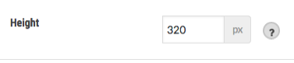
34. Background Color -- Sets the background color of the main part of the widget.

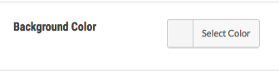
35. Background Image -- Sets the background image of the main part of the widget.

36. Background Repeat -- Sets the type of repetition of the background image of the main part of the widget.

37. Background Opacity -- Sets the transparency level of the background image of the main part of the widget.
38. Border -- This option is used to set the margins of the main part of the widget.
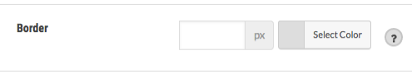
39. Border Radius – Sets the curvature of the line the edge of the main part of the widget.
40. Text Color -- Sets the text color of the main part of the widget.
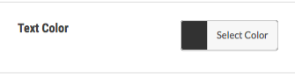
41. Font Size -- Sets the font size of the main part of the widget.
42. Font Family -- Sets the type font of the main part of the widget.

Chat Bubble
This section contains options for controlling the display of the chat box. The following options are available:
43. Background Color -- Sets the background color of the chat box.
44. Border -- Sets the margins on the chat box.
45. Border Radius -- Sets the curvature of the edge line of the chat box.
46. Text Color – Sets the text color of the chat box.
47. Font Size -- Sets the font size of the chat box.
48. Font Family -- Sets the type font of the chat box.

49. Shadow – Sets whether or not to add shadow effects on the chat box.
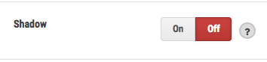
50. Arrow -- Sets whether or not to add decoration arrow on the chat box.
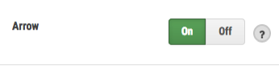
51. User Photo -- Sets whether or not to display pictures in the chat box.
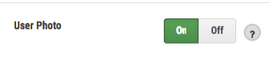

Form
This section contains options for controlling the display of input form. The following options are available:
52. Background Color -- Sets the background color of the input form.
53. Border -- Sets the margins on the input form.
54. Border Radius -- Sets the curvature of the line the edge of the input form.

55. Text Color -- Sets the text color of the input form.
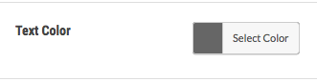
56. Font Size -- Sets the font size of the input form.
57. Font Family -- Sets the font type of input form.
Submit Button
This section explains the various options to set the appearance of a form submit button.
58. Button Icon – Sets the icon on the submit button.
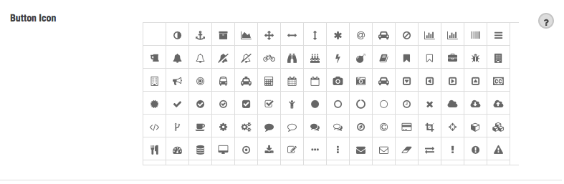
59. Background Color -- Sets the background color of the submit button.
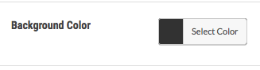

60. Border -- Sets the margins on the submit button.
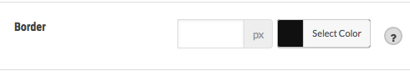
61. Border Radius -- Sets the curvature of the line the edge of the submit button.
62. Text Color -- Sets the text color of the submit button.

Effect
This section contains options to set the effect of the widget. The following options are available:
63. Shadow -- Sets whether to add shadow effects on the widget.
64. Sending Chat Sound -- This option is used to adjust the sound / music that is played when a user sends a new chat message.
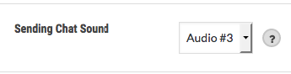
65. News Chat Sound -- This option is used to adjust the sound / music that is played when there is a new chat message.
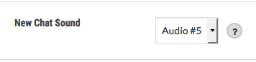

WIDGET SHOW EFFECT
This section explains the various options to set the animation effect when the widget is displayed.
66. Default Show / Hide -- Sets whether or not the page is first loaded, it will display the main content or just the tab key.
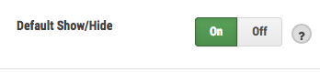
67. Animation Type -- Sets the type of animation when the widget is displayed.
68. Animation Speed -- This option is used to control the speed of the animation when the widget is displayed.
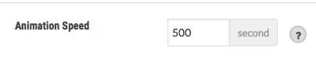

Adjusting Chat Features

In addition to the widget display, you can set how the plugin will run the main features of this plugin. You can do so by accessing the settings page via the Settings menu on the left.

The following explains the various options provided:

General
This section contains the most common options for the live chat feature.
1. Widget visibility -- Sets whether to show or hide the widget.
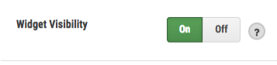
2. Online Status -- Sets the status online / offline. If the status is set to offline, the user can only send messages offline.
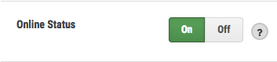
3. Restricted User -- Sets whether or not only the user who logged in can use the live chat feature.
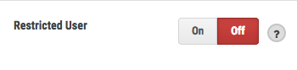

Content
This section contains options to set the content of information or messages from a live chat feature.
1. Online Info -- Sets the information to display to indicate that you are online.
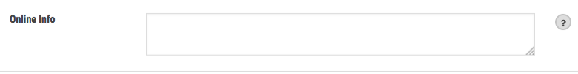
2. Offline Info – Sets the message to display to indicate that you are offline.

MESSAGE
This section explains the options for the content of the messages that appear as a result of user interaction to a live chat feature.
3. Offline Message -- Sets the message that is displayed to notify the user when the admin is offline.
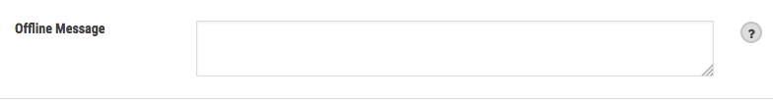
4. Success Send Offline Message -- Sets the message displayed when the user has successfully sent an offline message.

5. Failed Offline Send Message -- Sets the message displayed when the user fails to send offline messages.
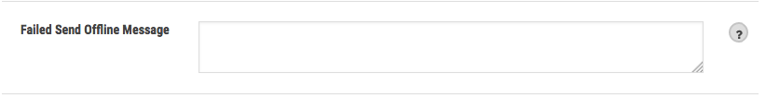
6. Success Register Message -- Sets the message displayed when the user successfully registers (to start chatting).

7. Failed Register Message -- This option is used to set the message displayed when the user fails to register (to start chatting).

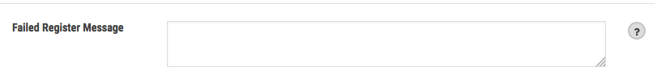

FORM
This section contains options to manage content form.
1. Input Name Labels -- Sets the label of the name input field.
2. Input Label Email – Sets the label of the email input field.
3. Input Label Phone -- Sets the label of the phone input field.
4. Input Message Label -- Sets the label of the message input field.

INPUT CHAT
This section explains the options for the content of the chat input box.
5. Input Chat Placeholder -- Sets the placeholder text of the chat input field.
6. Submit Button Label – Sets the label of the submit button.

FORM OFFLINE MESSAGE

This section will explain the options available to set the content of the offline messages.
7. Input Name -- Sets whether or not to show the input name.
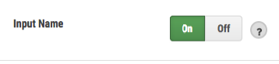
8. Input Phone -- Sets whether or not to display the phone number input.
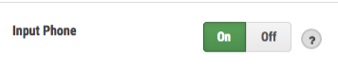
9. Submit Button Label -- Sets the label of the submit button.

REGISTER FORM MESSAGE
This section explains the options to set the content of the register form (when the user will start the process of chatting).
10. Name Input -- Sets whether or not to show the input name.
11. Input Phone -- Sets whether or not to display the phone number input.
12. Submit Button Label -- Sets the label of the submit button.

USER
This section contains the options to set the name and icon / user pictures to be displayed on every conversation.
1. Name Admin -- Sets the administrator name as shown on each talk.
2. Admin Photo -- Sets the photo of the administrator that is displayed on every conversation.
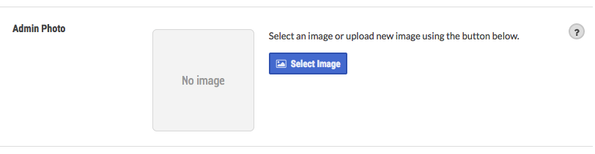
3. User Photo Type -- Sets the type of user photo displayed on every conversation.
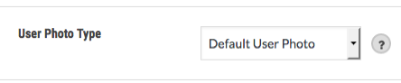
4. Default User Photos -- Sets the default photo of the user that is displayed on every conversation.
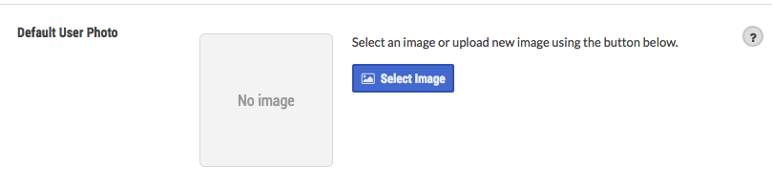

NOTIFICATION
This section contains various options to set the notifications will be sent via email to the administrator on any user interaction to a live chat feature.
1. Notification Email -- Sets the email address to send the notification to.
2. New Chat Notification -- Sets whether or not to send an email notification when new chat is initiated.
3. Offline Chat Notification -- Sets whether or not to send an email notification when new messages offline is initiated.
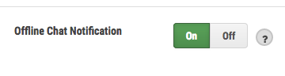

ADMIN CHAT
This is the main section where the administrator can communicate with the user directly.
NOTE: Admin is ONLY shown online when the “Chat Tab” inside admin area is in focus.
1. To start a chat, you can click on one of the user on the left side.
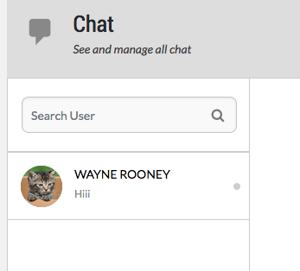

2. You can only send chat to the online user. Every online user will be marked with a green dot.
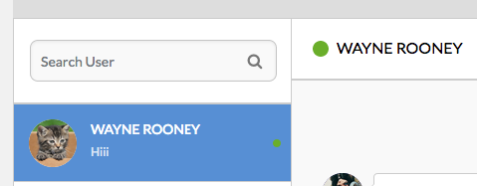
3. To send a chat, you can use the chat input that is in the bottom right.
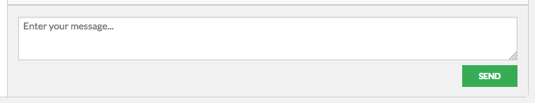
4. To manage any chat to a user you can use over the next option.
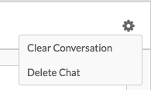

OFFLINE MESSAGE
This section is where the administrator can manage offline messages. Here's an explanation of each of the features in the offline page message.
1. View the Message List
To view the list of offline messages sent, click the menu link found in the left sidebar of the WordPress Dashboard as shown below.

2. View Message
To view the messages in detail, you may click on the name of the sender or the existing View Message button on the right of each item message.
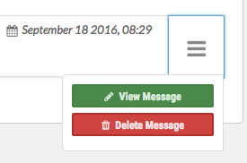

3. Delete Message
To view the messages in detail, click on the Delete Message button on the right of each message item.

IV. USERS LIST
In this section you can view a list of all users who have ever communicated with you. With a user list it is easier for you to call back a user using other communication media.
To access this page Users can use the menu on the left.

