Secrets of Successful Candle Making

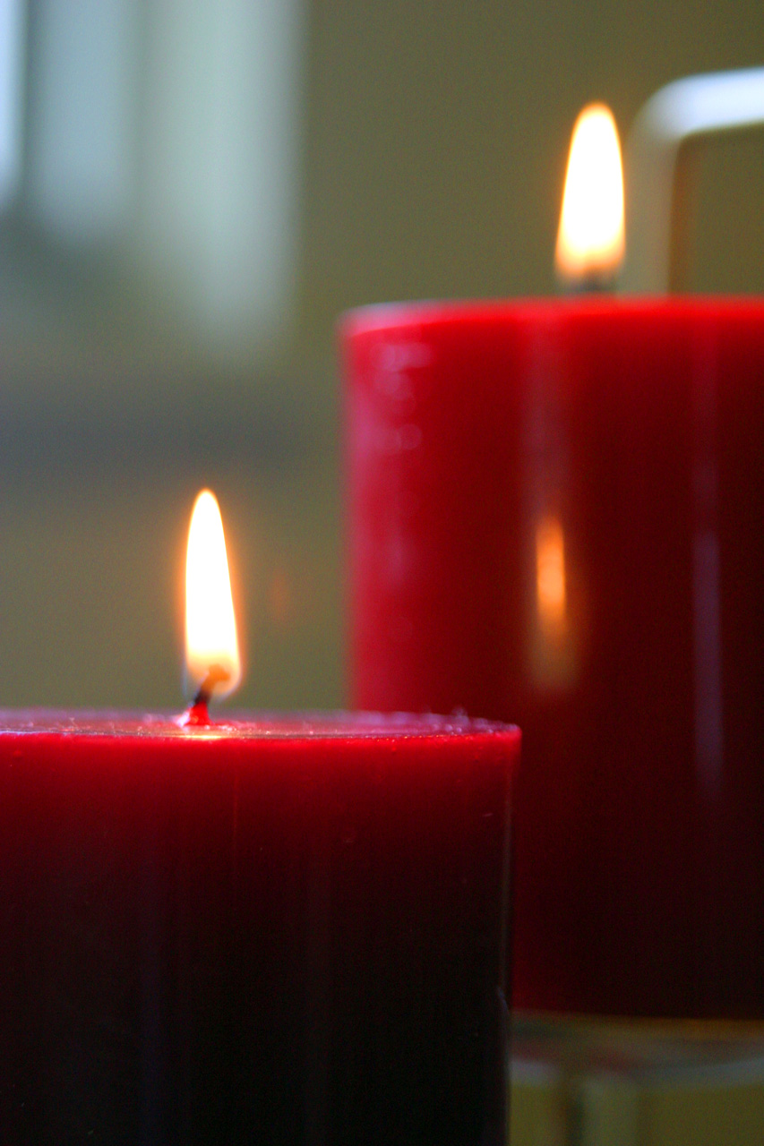

Secrets to Successful Candle Making
Table of Contents

Introduction
Page 3

Chapter One: History of Candles and Candle Making
Page 6

Chapter Two: Candle Making Supplies
Page 16

Chapter Three: What Every Candle Needs: Wax, Wick, Color and Scent
Page 22

Chapter Four: The Basic Steps and Troubleshooting
Page 36

Chapter Five: Making Candles
Page 48

Chapter Six: Candles As Gift Ideas
Page 67

Chapter Seven: Make a Wish and Blow Out a Candle: Making Your Business Dreams Come True
Page 72

Conclusion
Page 78

Appendix: Essential Tools of Candle Making
Page 79

References
Page 80
Introduction

They say confession is good for the soul. I'm not sure that's true, but I do have a confession to make: I am not a naturally born craft aficionado.

In fact, for most of my teen and adult life, I resisted any activity that had the word "craft" attached to it. I don't knit. I don't crochet. Let's face, I try real hard not even to cook. (Only when my back is up against the wall.)

I caved in once with the craft activity. I got talked into trying my hand at "stamping." You know what I'm talking about. Those stamp pads with the cute designs, stamp some ink on them, then create fabulous cards, letterhead and who knows what else.

The woman I was with created stunning pieces of stationery. Mine looked like a first grader did it!
Why do I tell you all of this? Because I am now a "dyed in the wool" official proponent of making candles. I can't believe how beautiful my projects turn out. My candles are so nice, in fact, that I have my own creations in just about every room of my house.

Not only that, but I've been presenting them as gifts to family and friends for the last several years -- birthdays, Christmas, Easter. No matter what the holiday, I have a candle for it. Geez, sometimes I give a candle just as an "I've-been-thinking-about-you" gift.

And people really appreciate them. That bolsters my self-esteem. And in fact, I've even started to sell them to various outlets -- with more success than I thought I would have.

There's really a point to all of this explanation. Even if you don't think that you're the "crafty" person, you may discover that candles bring out the inner craftsperson in you. It certainly did in me.

Even if you've shunned -- or more appropriately failed -- at every other craft, you'll find that candle making is unlike any other craft you've ever done.

For one thing, you really don't need to have any inner type of talent. Let's face it, if I can be successful at making candles anyone can!

If you're thinking of starting this quite fascinating hobby, then by all means, do. Don't let past failures at craft projects hold you back. Don't let a lack of "craft knowledge" place any type of doubt in your mind.

Candle making is, without a doubt, the most fun you'll ever have creating anything. By the time you've completed your first candle, your wax won't be the only thing that will be melted.

Your heart will melt as well, because you'd have fallen in love with this easy activity. But you'll also love this activity because it won't send your checking account plummeting into double digit deficits.

You can easily start your hobby on items you probably already have around the house already.

How to Use This Book Wisely

Read through this book once without starting a single project (if you think you have the will power). Then go back to the beginning chapters that talk about equipment. When you're ready to tackle your first project, line up everything you'll need.

It's best to get all your ducks in a row (so to speak) so that you can quickly and efficiently work with the hot wax. If you have to, reread the specific section again. In this way, you'll have little firmer grasp of what needs to be done. You'll feel a little more confident.

As you encounter projects or ideas, be sure to reread the relevant sections at least once -- twice if you want. Don't be bashful about returning to these pages to read and reread them again!

In fact, print out certain sections that you may want to consult while you're making your candles. Have them on your counter along with all your other supplies, just like you would have your favorite recipe available for consulting when you're making a meal.

In the process of referring back to this book often, you'll discover that you're slowly becoming a candle making pro. But more than that I can guess that you'll also start to love this easy-to-do craft.

After you make your first candle, my bet is that you'll take a step back, take a good look at it and then display it someplace where everyone who steps foot in your house can admire it! That's what I did anyway!

This book introduces you to the various types of candles from paraffin to beeswax to gel. As you progress through these various projects, you'll also discover that your imagination gets fired up! You'll want to keep making these candles.

And you'll find yourself continuing, as your friends and families stand in line for custom-made candles to suit the décor of their homes or for gifts for their friends and coworkers.

And you might possibly get fired up about spreading the word about candle making even more! You may end up considering it as a part-time business. Don't laugh! It's really not out of the question. Even if you just sold locally, you can make a nice income -- especially if you have unique versions of candles that people can't find in stores. Just keep it in mind as you read! The last chapter in this book provides you with some statistics on who actually uses candles, and where. It also provides you with some rudimentary marketing tips . . . enough to get you started should you decide to become that part-time entrepreneur.

Are you ready to discover a remarkably easy, extremely fun . . . and potentially profitable hobby?

Well, let's start then. Time's a'wastin'.

